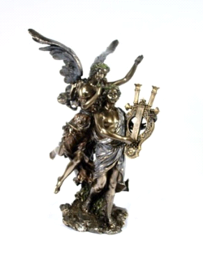
12th INTERNATIONAL MUSIC COMPETITION
,,HEIRS OF ORPHEUS” (online)

ALBENA, BULGARIA
02nd – 12th September 2025
----------------------------------------------------------------------------------------------------------------
WINNERS GALA CONCERT
1.
Laureate of I Prize
Diploma for the youngest participant of the Competition (b. 2020)
Niya Ninova - Piano I a. g.
The USA / Bulgaria
Teacher Veselin Ninov
- P. I. Tchaikovsky. Song of the Lark, Op. 39 1`30``
https://youtube.com/shorts/4KGOIOwPtBw?si=ddBinYxb9MokdXRI
2.
Laureates of I Prize
Selestina Topic - Flute II a. g.
National School of Music and Dance Art “Dobrin Petkov” Plovdiv, Bulgaria
Teacher Prof. Borislav Yasenov
- P. Vladigerov. “Sitno horo” 4`00``
https://youtu.be/hcKJD3UsvhQhttps://youtu.be/hcKJD3UsvhQ
3.
Laureate of I Prize
Dmytro Sakovych) - Chromatic Harmonica IV a. g. Hohner Conservatory Trossingen, Germany / Ukraine
Teacher Naoko Nebl
- Ernesto Lecuona. Malaguena 6`49``
https://youtu.be/P8KdycFf5ho
4.
Laureate of I Prize
Ruslan Ermakov - Piano III a. g.
New York, USA / Russian Federation
Teacher Ilya Ishchenko
- F. Chopin. Ballade No. 3 in A-flat Major, Op. 47 7:24 https://youtu.be/fcaPl_QZtrU
5.
Laureate of I Prize
Hongyu Liu – Jazz Guitar I a. g.
Shanghai Conservatory of Music, China
Teacher Assoc. Prof. Xiongguan Zhang
- Pat Martino. “Days of wine and roses” 3`10``
https://youtu.be/17_32SYOSco
6.
Laureate of I Prize
Special Diploma for the best performance of work by Bozza
Haotian Jia- Flute IV a. g.
Zhejiang Conservatory of Music, China
Teacher Zhenzhen Fu
- Eugène Bozza. “Image” for Flute solo 4`18``
https://youtu.be/LCz9AWrPXh0
7.
Laureate of I Prize
Zijun Wu – Piano V a. g., China
- I. Stravinsky. The Firebird, 12`15``
https://youtu.be/kZToLSwiSW4

